}

Guía1. Definición Proyecto APT
Asignatura Capstone

- PARTE I
1. Antecedentes Personales
A continuación, se presenta una tabla en la que debes completar la información solicitada.

Nombre estudiante | Dante Vargas Donoso  Daniel Jofre  Ismael Tapia
Rut | 20.838.668-9  21.347.357-3  21.216.536-0
Carrera | Computer Engineering
Sede | Viña del Mar

2. Descripción Proyecto APT
En la descripción debes señalar brevemente el nombre de tu proyecto APT y las competencias del perfil de egreso que vas a poner en práctica. Si en tu carrera están definidas las áreas de desempeño, también menciona a qué áreas de desempeño está vinculado el proyecto.

Nombre del proyecto | AlertaVital
Área (s) de desempeño(s) | Computer Engineering, Applied Artificial Intelligence, Digital Health, Mobile technologies, Geolocation Systems, Accessibility and Usability.
Competencias | Manage IT projects, offering alternatives for decision-making according to the organization’s requirements.  Build data models to support the organization’s requirements based on a defined and scalable design over time.  Develop a software solution using techniques that systematize the development and maintenance process, ensuring the achievement of objectives.  Perform certification tests on both products and processes using industry-defined best practices.

3. Fundamentación Proyecto APT
A continuación, se presentan distintos campos que debes completar con la información solicitada. Esta sección busca que describas en detalle tu proyecto y justifiques su relevancia y pertinencia.

Relevancia del proyecto APT | The project addresses a critical issue: loneliness and unreported accidents among older adults, especially in Chile. Recent research confirms that loneliness and social isolation directly affect the resilience and health of this population.  - A national study conducted during the pandemic showed that older adults reporting loneliness were 1.8 times more likely to have low resilience, limiting their ability to seek help or recover after a fall. 69% of respondents were women, reflecting a relevant gender component (Oppenheimer-Lewin et al., 2022).  - Qualitative studies in central Chile revealed that confinement increased sadness, isolation, and reduced physical activity, affecting autonomy and overall health (Almonacid-Fierro & Almonacid-Fierro, 2021). This reduction in mobility and exercise is a key risk factor for falls.  - A study in Chillán found significant differences in fall risk among self-sufficient older adults depending on their physical activity, balance, and medication use. There was a strong correlation between reduced balance (static and dynamic) and higher fall risk (Tapia Villalobos & Molina Márquez, 2020).  - Gender also influences vulnerability. Although being female was linked to greater resilience, older women in Chile are more likely to live alone and present depressive symptoms, increasing their exposure to risks without adequate support systems (Oppenheimer-Lewin et al., 2022).  Summary: In Chile, evidence shows that loneliness, social isolation, and reduced physical activity are closely linked to unreported falls and severe health consequences in older adults. This reinforces the need to design low-cost, accessible technological solutions adapted to this reality, with emphasis on women, rural populations, and vulnerable groups.  The project is significant as it applies artificial intelligence, mobile IoT, and digital accessibility to a real public health problem, providing technological solutions that improve quality of life and reduce risks in a highly vulnerable group.
Descripción del Proyecto APT | We propose developing an accessible mobile app for older adults that uses smartphone sensors (accelerometer and gyroscope) to detect falls and prolonged immobility.  - The system applies a hybrid AI model (rules + lightweight machine learning) to distinguish between real events and false positives.  - On detecting a suspicious event, the app triggers a 20-second countdown with an “I’m OK” button.  - If not canceled, it automatically sends an alert with GPS location via SMS to pre-defined contacts (neighbors or family).  - Contacts receive a map link with quick options (“I’m going”, “I’m with him/her”, “False alarm”), enabling real-time coordination of help.
Pertinencia del proyecto con el perfil de egreso | The project aligns with the Computer Engineering graduation profile by integrating competencies in:  - Multiplatform software development (Flutter, Node.js).  - Applying artificial intelligence and machine learning to real-world problems.  - Designing solutions focused on accessibility and digital inclusion.  - Managing technology projects from planning to user testing.  Thus, the project applies technical knowledge while addressing a high-impact social issue: improving safety and quality of life for older adults living alone, reducing unreported accidents and preventable deaths.
Relación con los intereses profesionales | Ismael: Sees the project as an opportunity for entrepreneurship and applying ML integration in production.  Dante: Values independent entrepreneurship, ML integration, and software development practice for future projects.  Daniel: Focuses on innovative solutions integrating AI, accessibility, and mobile apps to solve social and health issues, strengthening his profile as a socially oriented computer engineer.
Factibilidad de desarrollo del Proyecto APT | The project is feasible within the semester duration, with a well-defined MVP scope (fall detection, automatic SMS alerts, basic web panel).  Resources: smartphone with basic sensors, internet connection, computer.  External factors: availability of studies, free libraries/frameworks (Flutter, Node.js, PostgreSQL).  Challenges: limited real-world testing with older adults and battery consumption. Mitigations: simulated tests and energy optimization.

- PARTE II
4. Objetivos
En este apartado debes definir objetivos generales y específicos del Proyecto APT. Es importante aclarar que los objetivos se deben plantear en forma clara, concisa y sin dar mayores explicaciones, es decir, deben entenderse por sí solos. Se sugiere redactarlos utilizando un verbo en infinitivo, pues ello obliga a precisar acciones concretas.

Objetivo general | Develop an accessible mobile app to detect falls and immobility in older adults using phone sensors and lightweight AI, sending automatic alerts to emergency contacts to reduce risks from unreported accidents.
Objetivos específicos | - Implement a fall/immobility detection module (rules + lightweight ML) to minimize false positives.  - Design and integrate an alert system with countdown and SMS messages including geolocation.  - Develop a Node.js + PostgreSQL backend to manage events, contacts, and emergency responses.  - Incorporate digital accessibility principles into the UI (clear typography, large buttons, audio/vibration notifications).  - Validate the app through simulated tests and adjust parameters accordingly.

5. Metodología
En el siguiente apartado deberás describir la metodología, propia de tu disciplina, que utilizarás para resolver el proyecto APT antes descrito, incluyendo las etapas y métodos de trabajo.

Descripción de la Metodología
Methodology: Agile (Scrum) adapted to academic context.

Stages:
Requirements gathering & design (MVP scope, accessibility criteria).
Technical design & architecture (Flutter, Node.js + PostgreSQL, Twilio).
Iterative development (sensors, alerts, backend, web panel).
Testing & validation (fall simulations, accessibility).
Documentation & final delivery (user manual, technical report).
Team Responsibilities:
Mobile dev (Flutter): Ismael Tapia.
Backend & DB: Daniel Jofre, Dante Vargas.
AI/ML: Dante Vargas, Daniel Jofre.
Project management & testing: Entire team.

6. Evidencias
A continuación, describe qué evidencias serán evaluadas en el informe de avance y en el informe final de tu proyecto APT. Estas evidencias deben ser acordadas con tu docente. Se entenderá por evidencia los productos que se desarrollen durante el proyecto y cuyo propósito sea visibilizar o documentar cómo se ha implementado el trabajo.

Tipo de evidencia  (avance o final) | Nombre de la evidencia | Descripción | Justificación

7. Plan de Trabajo
En la siguiente tabla define la planificación de tu Proyecto APT de acuerdo a lo requerido.

Plan de Trabajo Proyecto APT
Competencia o unidades de competencias | Nombre de Actividades/Tareas | Descripción Actividades/Tareas | Recursos | Duración de la actividad | Responsable | Observaciones
Multiplatform Dev | Requirements & Design | Define MVP scope, user flows, accessibility criteria | PC, internet, bibliography | 1 week | Whole team | Teacher review
Mobile Programming | Fall detection module | Configure sensors, apply rules & countdown | Flutter, sensors_plus | 2 week | Ismael (main), Daniel (review) | Battery adjustments
Applied AI | ML model integration | Train Logistic Regression, export coefficients, integrate | Python, scikit-learn | 1 week | Dante, Daniel | Needs simulated falls
Backend Dev | API & DB | Build REST API in Node.js + PostgreSQL | Node.js, PostgreSQL | 1 week | Dante, Daniel | Include logging
Messaging Integration | WhatsApp + SMS | Configure WhatsApp Cloud API + Twilio fallback | Cloud API, Twilio | 1 week | Daniel | Check costs
Web Technologies | Alert web page | Leaflet map with response buttons | HTML, JS, Leaflet | 1 week | Ismael | Linked from SMS/WSP
Validation & Testing | Simulations | Test detection, alerts, contact responses | Android phone | 1 week | Whole team | Simulate offline scenarios
Documentation & Delivery | Final report/presentation | Write technical report, MVP demo | Word, PowerPoint | 1 week | Whole team | Deliver before Dec.

8. Carta Gantt
Busca un formato de Carta Gantt que te acomode y organiza en este las actividades planificadas en el punto anterior considerando el periodo asignado para el desarrollo de tu Proyecto APT. Debes mantener la temporalidad del periodo académico en el desarrollo de las tres fases que contempla la Asignatura de Portafolio de Título.

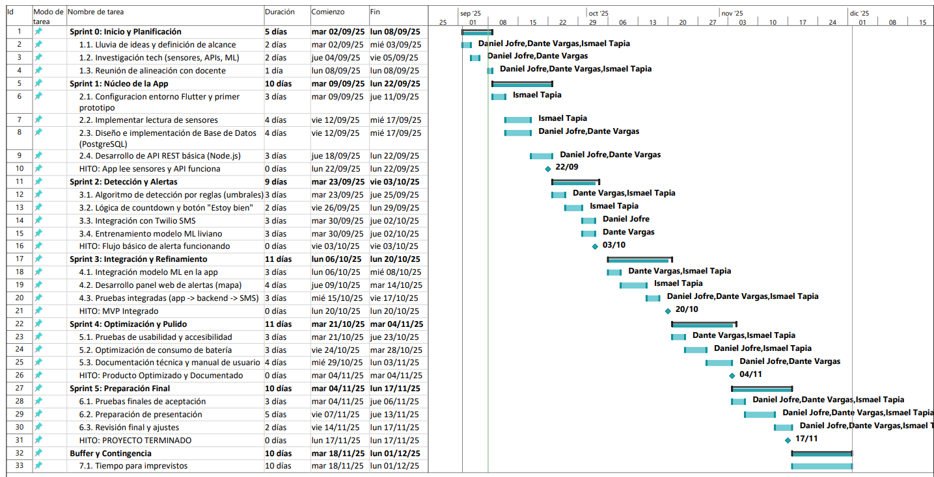

En caso de que el Proyecto APT sea grupal, en esta columna deben indicar el nombre de los responsables de cada tarea o actividad. Esto posteriormente permitirá diferenciar la evaluación por cada integrante.

